Nama : Dimas Shofa Gunarso

NIM : 18090061

Kelas : 5D

**Praktikum 3**

1. Source Code

view-from-matakuliah.php->application/views

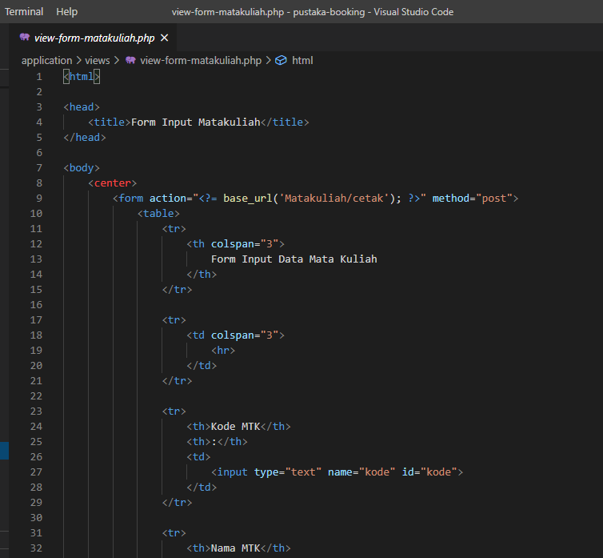

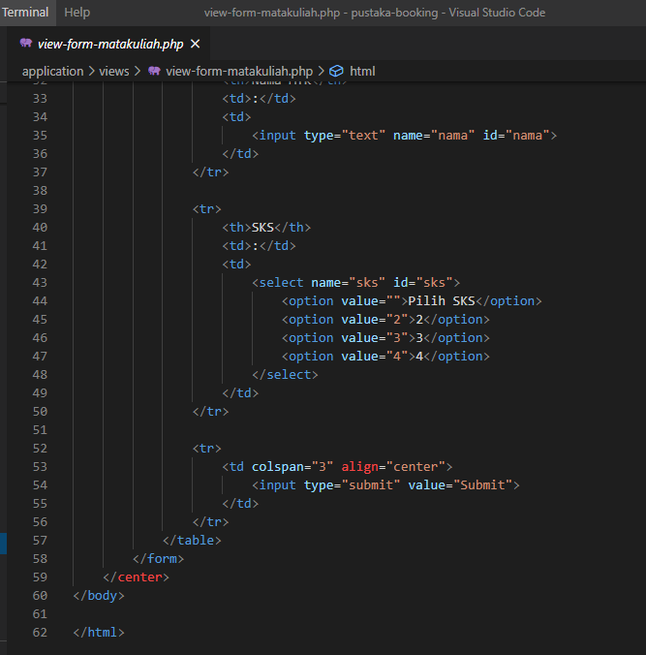

matakuliah.php ->application/controllers

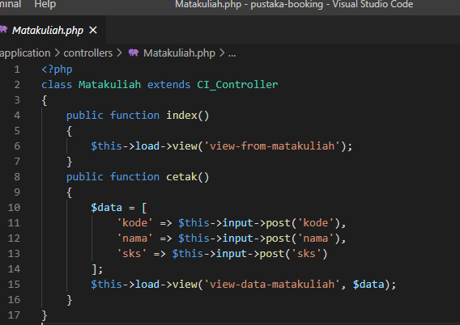

1. Hasil URL

[localhost/pustaka-booking/Matakuliah](http://localhost/5/pustakachoco/index.php/matakuliah)

1. Capture Hasil

